**HYDERABAD METRO RAIL**

*A*

*Project Report*

*Submitted in partial fulfilment of the Requirements for the award of the Degree of*

**BACHELOR OF ENGINEERING**

IN

**INFORMATION TECHNOLOGY**

By

**K. RISHITHA REDDY (1602-17-737-094)**

**K. SUPREETH (1602-17-737-110)**

**T. ARAVIND (1602-17-737-318)**

*Under the guidance of*

**G. RAJASHEKAR**

**Assistant Professor**



**Department of Information Technology**

**Vasavi College of Engineering (Autonomous) (Affiliated to Osmania University) Ibrahimbagh, Hyderabad-31**

**2019-2020**

**Vasavi College of Engineering (Autonomous) (Affiliated to Osmania University) Hyderabad-500 031**

**Department of Information Technology**

**DECLARATION BY THE CANDIDATE**



I, **K. RISHITHA REDDY, K. SUPREETH, T. ARAVIND** bearing hall ticket number **1602-17-737-094, 1602-17-737-110, 1602-17-737-318** hereby declare that the project report entitled **“HYDERABAD METRO RAIL”** under the guidance of **G. RAJASHEKAR**, Assistant Professor, Department of Information Technology, Vasavi College of Engineering, Hyderabad, is submitted in partial fulfilment of the requirement for the award of the degree of **Bachelor of Engineering** in **Information Technology.**

This is a record of bonafide work carried out by me and the results embodied in this project report have not been submitted to any other university or institute for the award of any other degree or diploma.

**K. RISHITHA REDDY (1602-17-737-094)**

**K. SUPREETH (1602-17-737-110)**

**T. ARAVIND (1602-17-737-318)**

**Vasavi College of Engineering (Autonomous) (Affiliated to Osmania University) Hyderabad-500 031**

**Department of Information Technology**



**BONAFIDE CERTIFICATE**

This is to certify that the project entitled “**HYDERABAD METRO RAIL”** being submitted by  **K. RISHITHA REDDY , K. SUPREETH , T. ARAVIND** bearing **1602-17- 737-094, 1602-17-737-110, 1602-17-737-318** in partial fulfilment of the requirements for the award of the degree of Bachelor of Engineering in Information Technology is a record of bonafide work carried out by him/her under my guidance.

**G. Rajashekar Dr. K. Ram Mohan Rao**

**Assistant Professor HOD, IT**

**ACKNOWLEDGEMENT**

The satisfaction that accompanies that the successful completion of the project would not have been possible without the kind support and help of many individuals. We would like to extend my sincere thanks to all of them.

We would like to take the opportunity to express our humble gratitude to our guide G. Rajashekar Sir and our coordinator R. Dharma Reddy Sir under whom we executed this project.

We would like to extend our thanks to our mentor S. Sai Harsha Rao (1602-16-737-048). We are grateful to his guidance, and constructive suggestions that helped us in the preparation of this project. His constant guidance and willingness to share his vast knowledge made us understand this project and its manifestations in great depths and helped us to complete the assigned tasks. We would like to thank all faculty members and staff of the Department of Information Technology for their generous help in various ways for the completion of this project.

Finally, yet importantly, we would like to express our heartfelt thanks to our HOD Dr. K. Ram Mohan Rao Sir and classmates for their help and wishes for the successful completion of this project.

**ABSTRACT**

This is an integrated service which provides all information about the metro rail and it’s routes for public. The proposed system is a web based application which provides information regarding timings, routes, fair. This system manages public feedback about services through it’s complaint management system. This system also contains an online ticket recharge module where users can recharge their smart cards online through the site. There is also an admin module where admin can add stations, trains, routes and also update the fairs. The admin is a panel consisting of a group of authorized persons.

**TABLE OF CONTENTS**

1. **Introduction................................................................................1**
   1. **Objectives**
2. **Overview.....................................................................................2**
   1. **Complaint Management Module**
   2. **Online Ticket Recharge Management**
   3. **Metro Time Table Module**
   4. **Fair and Route Map Module**
   5. **Admin Module**
3. **Proposed System........................................................................5**
4. **Requirement Specification.......................................................6**
   1. **General Description**
      1. **Product Description**
      2. **System Objectives**
5. **System Requirements...............................................................7**
   1. **Non-Functional Requirements**
   2. **Functional Requirements**
6. **Software and Hardware Requirements.................................10**
7. **System Design..........................................................................11**
   1. **Database**
   2. **System Tools**
8. **ER Diagram.............................................................................12**
   1. **Complaint Management**
   2. **Route and Trip Management**
9. **Data Flow Diagram.................................................................14**
10. **Results......................................................................................17**
11. **Future Scope............................................................................19**
12. **Conclusion...............................................................................20**
13. **References................................................................................21**

**LIST OF FIGURES**

1. **Complaint Management Module**
2. **Ticket Recharge Management**
3. **Metro Time Table Module**
4. **Fair and Route Module**
5. **Admin Module**
6. **Complaint Management**
7. **Route and Trip Management**
8. **Admin Data Flow Diagram**
9. **Complaint Management System Data Flow Diagram**
10. **Online Ticket Recharge Data Flow Diagram**
11. **Fair and Route Data Flow Diagram**
12. **Trip Data Flow Diagram**
13. **Route and Fair for User’s Journey**
14. **Complaint Registration by User**
15. **Add new station by Admin**
16. **Reply to Complaints by Admin**
17. **INTRODUCTION**

The proposed system is a Web based application which provides information of metro trains regarding timings, routes and fair. There are two users namely admin and user. An admin module is where the admin can view and reply to complaints, issue smart card, add stations, add train, add routes, add and update fair details, add trips and also add a new admin. There is a complaint management system where users can file complaints regarding their issues. The system also contains an online ticket recharge module where users can recharge their smart cards online through the site.

**1.1. OBJECTIVES**

The objectives of the system are as follows:

* Users can view the metro timetable.
* Users can register complaints through the site.
* Users can view the fair details.
* Users can apply for a metro card and recharge, check it’s balance.
* Admin can add new stations.
* Admin can add new routes.
* Admin can manage the trains.
* Admin can add new fares.
* Admin can add a new admin.
* Admin can reply to the complaints which users have registered.
* Admin can issue a metro card to the users on request.

1. **OVERVIEW**

Metro Rail Management System comprises of modules which help in the overall functioning of the system. It consists of several implementation modules such as Complaint Management Module, Online Ticket Recharge Module, Metro Time Table Module, Fair and Route Module, Admin Module. These modules are discussed below:

**2.1. Complaint Management Module:**

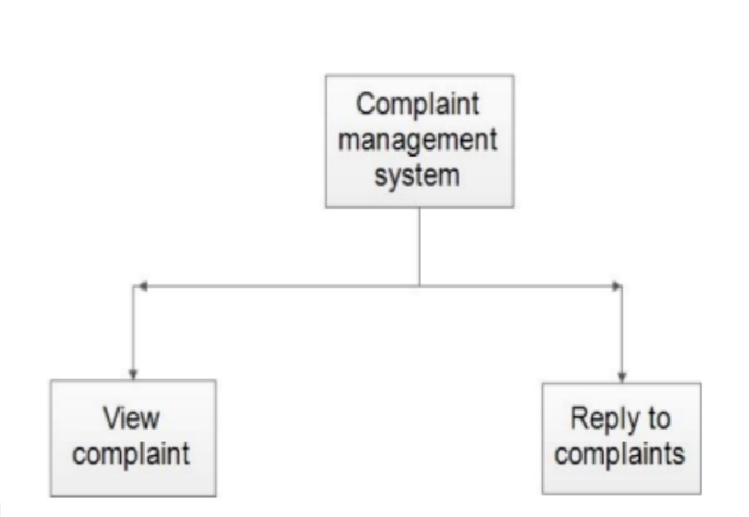

Figure 1: Complaint Management Module

The complaint management module has two main functions- view complaints and reply to complaints. The user can enter their personal details and file a complaint regarding the issue they are facing. The admin can view the users complaints and reply to the complaints.

**2.2. Online Ticket Recharge Management:**

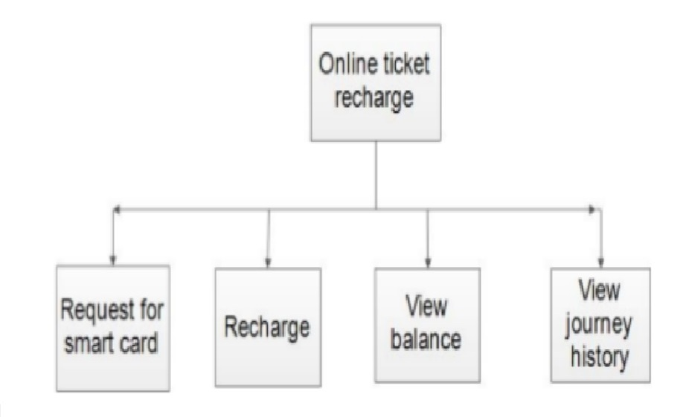

Figure 2: Ticket Recharge Management

A user can request for a smart card. The admin can accept the user’s request and issue a smart card with a unique card number for the user. The user can then use his card with the number and password. He can view the balance in his card and also recharge the card.

**2.3. Metro Time Table Module:**

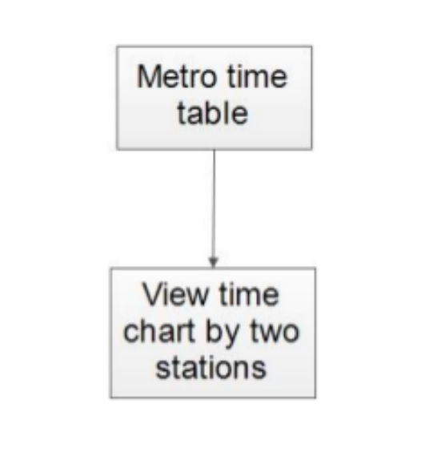

Figure 3: Metro time Table Module

The metro time table module will display the train number along with arrival and departure times for both source and destination stations. The chart of trains is displayed after the user enters source and destination stations.

**2.4. Fair and Route Map Module:**

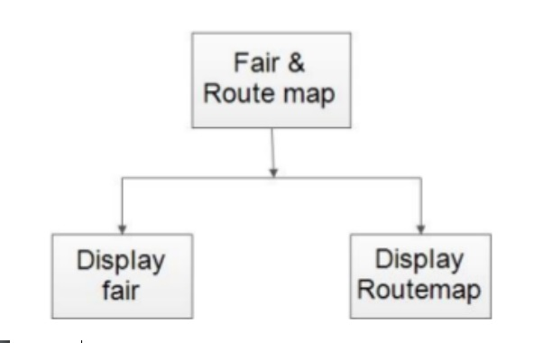

Figure 4: Fair and Route Map Module

The user on entering the source and destination stations, the fair and route map module will provide the information regarding the travelling charges and the route for the user’s journey.

**2.5. Admin Module:**

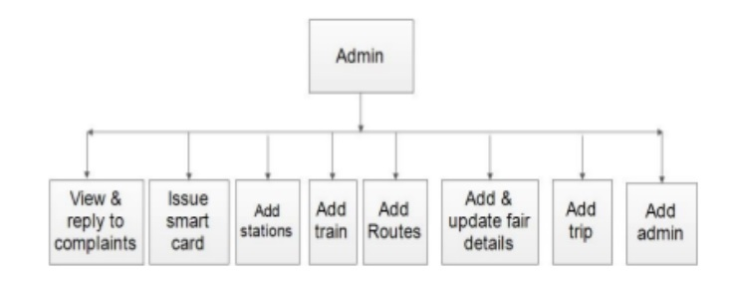

Figure 5: Admin Module

The admin can view and reply to the complaints which users file, issue a smart card on user’s request, add stations, add trains, add routes, add and update the fair details, add trips and also add a new admin.

1. **PROPOSED SYSTEM**

The proposed system is designed to eliminate the disadvantages of the existing system. The proposed system “Metro Rail Management System” is mentioned for tracing the problems in the existing system.

* Increased efficiency and reliability.
* Easier Access.
* Easy to us.
* Provide accurate information to the user for taking necessary decisions.
* Accuracy - The information will be correct, accurate and unambiguous.
* Efficiency - information can be collected, processed and communicated more quickly and efficiently.
* Systems ensure that right information reaches the right person at the right time.
* Reliability - Since systems are free from boredom and tiredness, they work constantly on data to produce more reliable outputs.
* Accessibility, Usability and Understandability.
* The options used can be easily accessed, used and realized.

1. **SYSTEM REQUIREMENT SPECIFICATION**

**4.1. General Description:**

**4.1.1. Product Description:**

Metro rail management system is an online system which helps the user to recharge their tickets online, it also has a complaint management system in which users can register their complaints online. By visiting the site, the users can get metro time table. Other than that, by entering the source station and destination station the users can get all sorts of information about trains arriving and departing from the stations, it’s fair details and even it provides you the route map.

**Problem Statement:**

The problem occurred before having online system includes

* File lost

When online system is not implemented the complaints are reported in files. The files are always lost due to some human errors.

* Time consuming

When there is no computerized system then for recharge purposes the users need to travel to the stations and also sometimes even need to stand in large queues for recharge purposes.

* Most updations are unnoticeable

When online systems are not implemented any changes in fair, timings etc. when updated, the details of these things are only available at the stations.

**4.1.2. System Objectives:**

* Improvement in Control and performance

The system is developed to cope up with current issues and problems of the metro rail. The system helps to recharge online, make a complaint online, display metro timetable, fairs and route maps.

* Save time

User is able to recharge online, see details of metro time table, fairs, route maps and even the user can complaint online there by saving his valuable time.

* Easy to Use

A person with just an internet connection and a PC can do things such as complaint, recharge and view metro details very easily.

1. **SYSTEM REQUIREMENTS**

**5.1. NON-FUNCTIONAL REQUIREMENTS:**

* Efficiency Requirement:

When a metro rail management system will be implemented then the user can recharge, complaint and view metro information quickly and easily.

* Reliability Requirement:

The system should accurately perform recharge, store complaints, show the details of metro such as fair, route maps.

* Usability Requirement:

The system is designed for a user-friendly environment so that user and admin of metro rail can perform various tasks easily and in an effective way.

* Implementation Requirements:

In implementing whole system, it uses HTML in front end with JSP as server-side scripting language which will be used for database connectivity and the back end i.e. the database part is developed using MySQL.

**5.2. FUNCTIONAL REQUIREMENTS:**

**5.2.1. Register Complaint:**

Description of the Feature:

This feature allows users to file complaints through the site. The user does not require a registration. He can give his name, email-id, phone number, address and other details along with the complaints. The admin will reply to the complaints sent by user.

Functional Requirements:

* System must be able to verify information.
* System must be able to store the information in database.
* System must be able to retrieve information when required by admin.

**5.2.2. Metro Card:**

Description of the Feature:

This feature allows the user to recharge their metro card online, thereby saving their valuable time. Users need to login with their card number and password so that they can recharge their tickets online. It also allows them to view their balance and journey history.

Functional Requirements:

* Card number is provided when admin issues a new card.
* The system must be able to show the users balance.
* The user must be able to logout after they had finished recharging or after viewing the balance or journey history.

**5.2.3. Metro Timetable:**

Description of the feature:

This feature allows the users to view the metro time table. Users are required to enter the source station and destination station, when they enter the data then the system will show the metro time table.

Functional Requirements:

* System must allow the users to enter the source station and destination stations.
* System must be able to process information from database.

**5.2.4. Admin:**

Description of the Feature:

This feature allows the admin to view and reply to complaints. Admin can add stations, routes, train, trip. Admin can also add and update fair details, and even add a new admin. Actually, the admin is a panel consisting of a group of authorized persons.

Functional Requirements:

* The system must allow admin to add train, stations, routes, fair, metro timetable and even add a new admin.
* The system must also allow admin to reply to the complaints send by the user.
* The system should be designed in such a way that only authorized people should be allowed to access some particular modules.
* The records should be modified by only administrators and no one else.

1. **SOFTWARE AND HARDWARE REQUIREMENTS**

**Software Requirements:**

* Operating system- Windows 10 is used as the operating system as it is stable and supports more features and is more user-friendly.
* Database MySQL-MySQL is used as database as it easy to maintain and retrieve records by simple queries which are in English language which are easy to understand and easy to write.
* Development tools and Programming language - HTML is used to write the whole code and develop webpages with CSS, java script, Bootstrap for styling work and JSP for sever side scripting.

**Hardware Requirements:**

* Intel core i5 7th generation is used as a processor because it is fast than other processors and is reliable and stable. We can also run our PC for longtime.
* Ram 8 GB is used as it will provide fast reading and writing capabilities and will in turn support in processing.

1. **SYSTEM DESIGN**

**7.1. DATABASE**

Database Design:

Databases are the storehouses of data used in the software systems. The data is stored in tables inside the database. Several tables are created for the manipulation of the data for the system. Two essential settings for a database are:

* Primary key - the field that is unique for all the record occurrences.
* Foreign key -the field used to set relation between tables.

Normalization is a technique to avoid redundancy in the tables.

**7.2. SYSTEM TOOLS**

**7.2.1. Front End:**

JSP, HTML, CSS, JAVA SCRITS are utilized to implement the frontend.

* Java Server Pages (JSP): Different pages in the applications are designed using JSP. A Java Server Pages component is a type of Java servlet that is designed to fulfil the role of a user interface for a Java web application. Web developers write JSPs as text files that combine HTML and embedded JSP actions and commands. Using JSP, one can collect input from users through web page.
* HTML (Hyper Text Markup Language): HTML is a syntax used to format a text document on the web.
* CSS (Cascading Style Sheets): CSS is a style sheet language used for describing the loo and formatting of a document written in a markup language.
* Java Script (JS): It is a dynamic computer programming language. It is most commonly used as part of web browsers, whose implementations allow client-side scripts to interact with the user, control the browser, communicate asynchronously, and alter the document content that is displayed.

**7.2.2. Back end:**

The back end is implemented using MySQL which is used to design the databases.

* MySQL: MySQL is the world's second most widely used open-source relational database management system (RDBMS). The SQL phrase stands for Structured Query Language. An application software called Xampp was used to design the tables in MySQL.

1. **ER DIAGRAM**

**8.1. Complaint Management:**

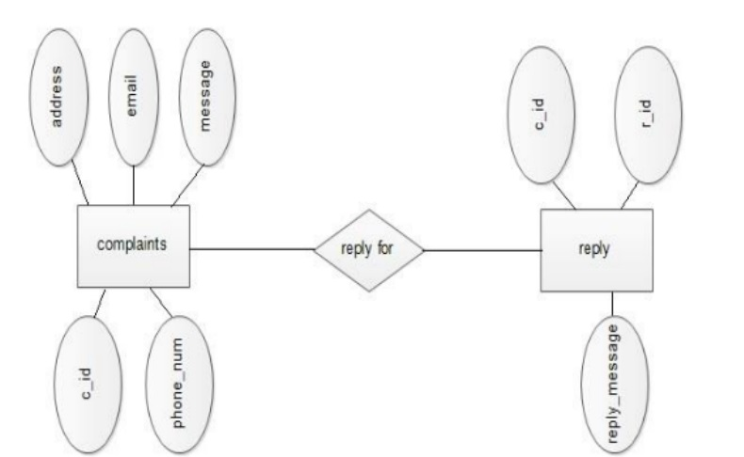

Figure 6: Complaint Management

The database contains complaints table and reply table. The complaints table has complaint id, phone number, address, email, message or complaint as attributes. The reply table has complaint id as a foreign key, reply id and the reply message. The admin will reply to the complaints which the user filed.

**8.2. Route and Trip Management:**

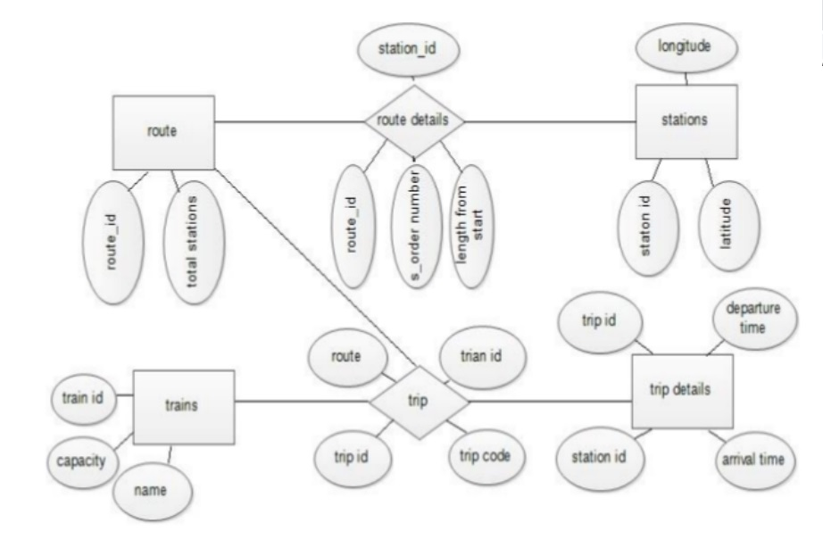

Figure 7: Route and Trip Management

The database has route table with route id and total stations, stations table with station id, latitude and longitude, trains table with train id, capacity and train name, trip details with trip id, station id, arrival time and departure time. For connecting these tables, we need other tables such as route details table and trip table. The route details table has station id as a foreign key from stations table, route id as a foreign key from route table, order number and length from the start. The trip table has trip id, train id as a foreign key from trains table, route and trip code. The stations are linked to the route using route details table which in turn takes trip table which links trains and trip details table.

1. **DATA FLOW DIAGRAM (DFD)**

**9.1. Data Flow Diagram for Admin**

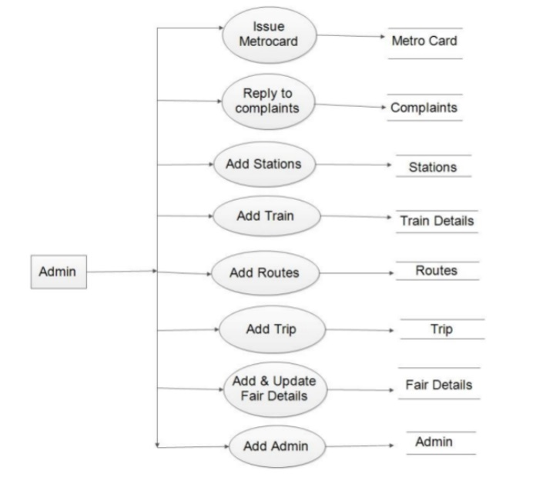

Figure 8: Admin Data Flow Diagram

The Admin can issue a metro card to the user on the user’s request, reply to complaints which the user has filed, add stations, add trains, add routes, add trips, add and update fair details and also can add a new admin.

**9.2. Data Flow Diagram for Complaint Management System**

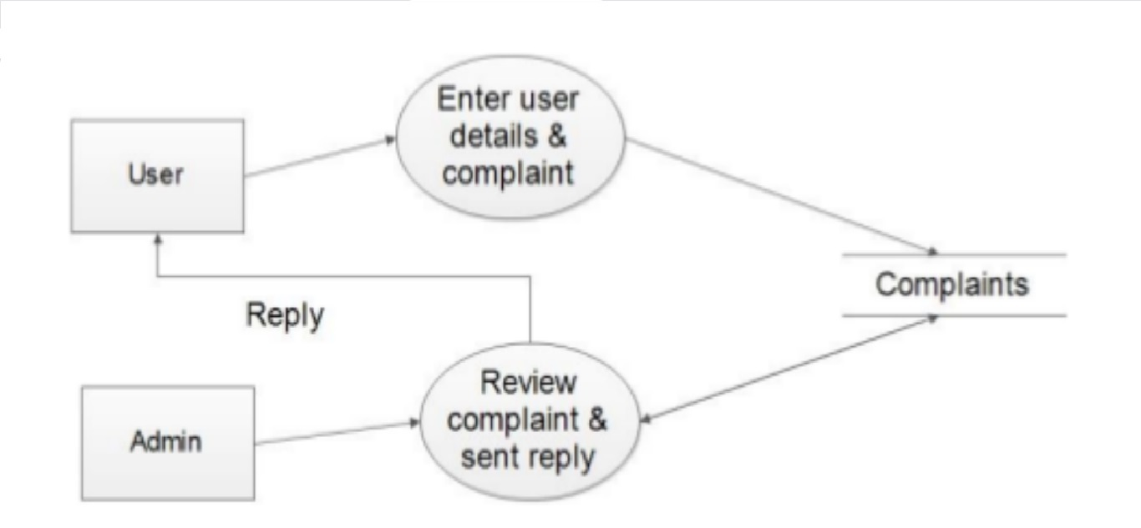

Figure 9: Complaint Management System Data Flow Diagram

The user can enter his details and file a complaint regarding his issue so that the admin can view and reply to the complaint.

**9.3. Data Flow Diagram for Online Ticket Recharge**

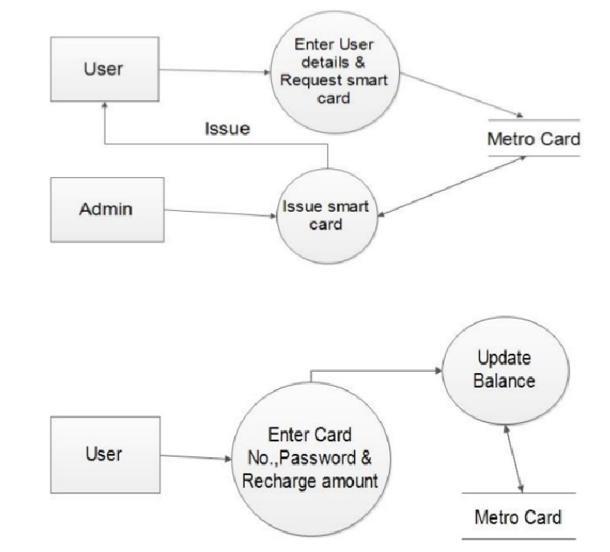

Figure 10: Online Ticket Recharge Data Flow Diagram

The user must enter his details and request for a smart card. The admin can then issue a smart card to the user with a unique card number. The user must recharge his card in order to use it for purchasing tickets before traveling. In order to recharge the card, the user must enter the card number and password along with the recharge amount. Then, the smart card’s balance is updated.

**9.4. Data Flow Diagram for Fair and Route details**

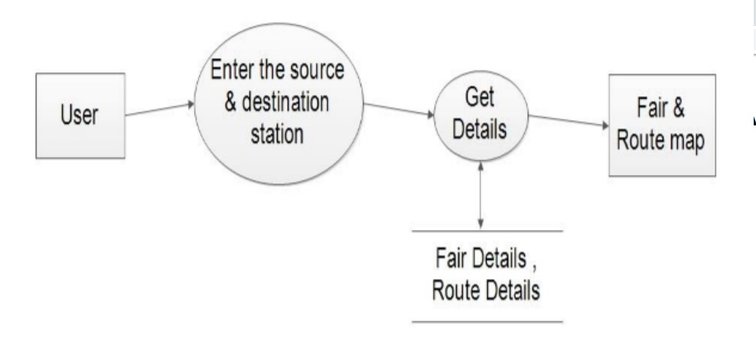

Figure 11: Fair and Route Data Flow Diagram

The user must enter the source and destination stations in order to get the details regarding the fair and route.

**9.5. Data Flow Diagram for Trip details**

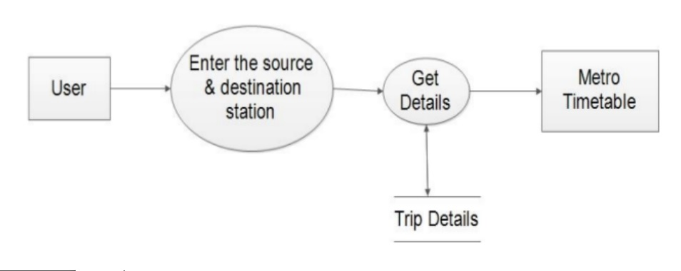

Figure 12: Trip Data Flow Diagram

The user must enter the source and destination stations in order to get the details of the metro timetable regarding the trip.

1. **RESULTS**

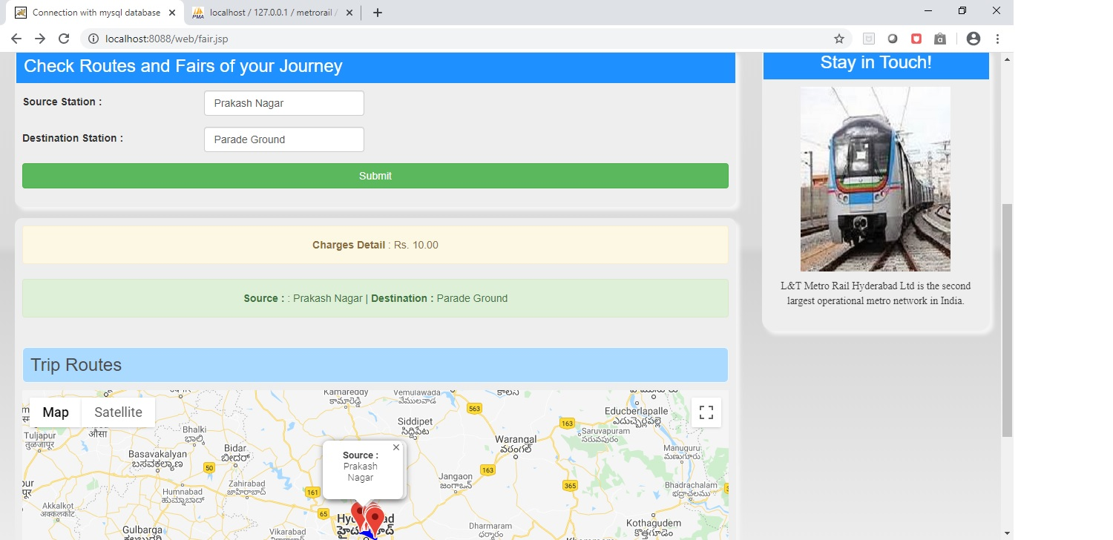

Figure 13: Route and Fair for User’s Journey

After the user enters the source and destination stations, the charges are displayed according to the distance between the source and destination stations. The route is also displayed via google maps.

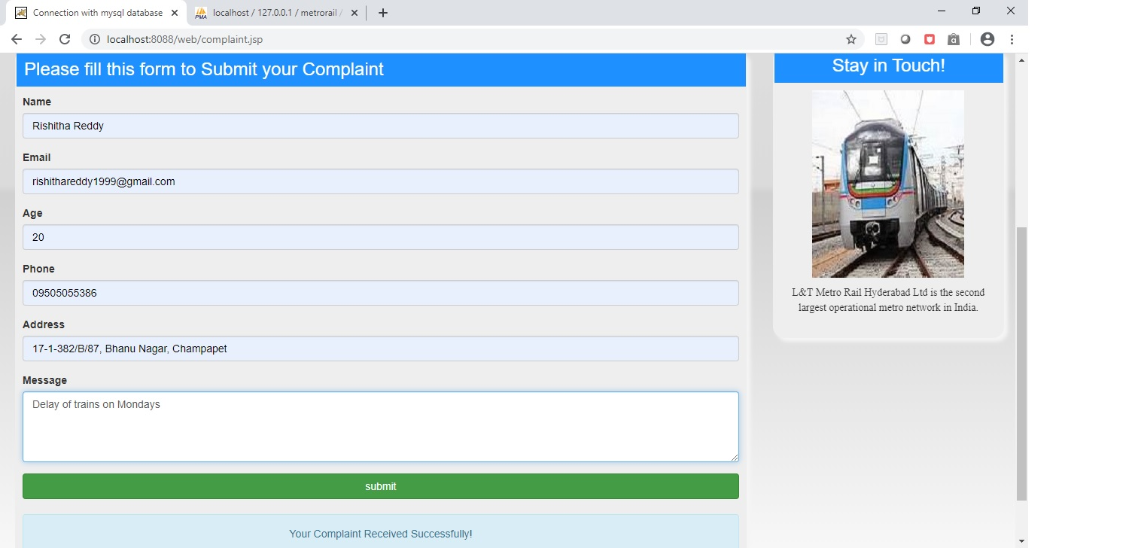

Figure 14: Complaint Registration by User

In order to register a complaint, the user must submit a form by filling the details such as name, email, age, phone number, address and the complaint message.

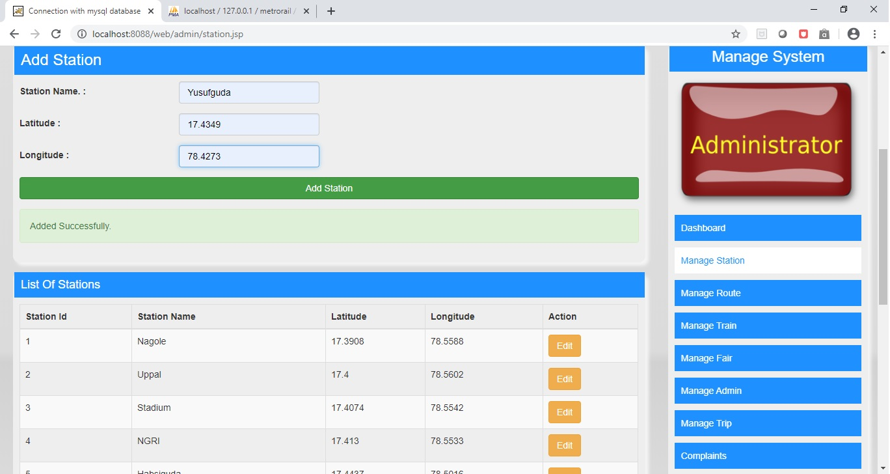

Figure 15: Add new station by Admin

The admin can add a new station by entering the station name, latitude and longitude of the station.

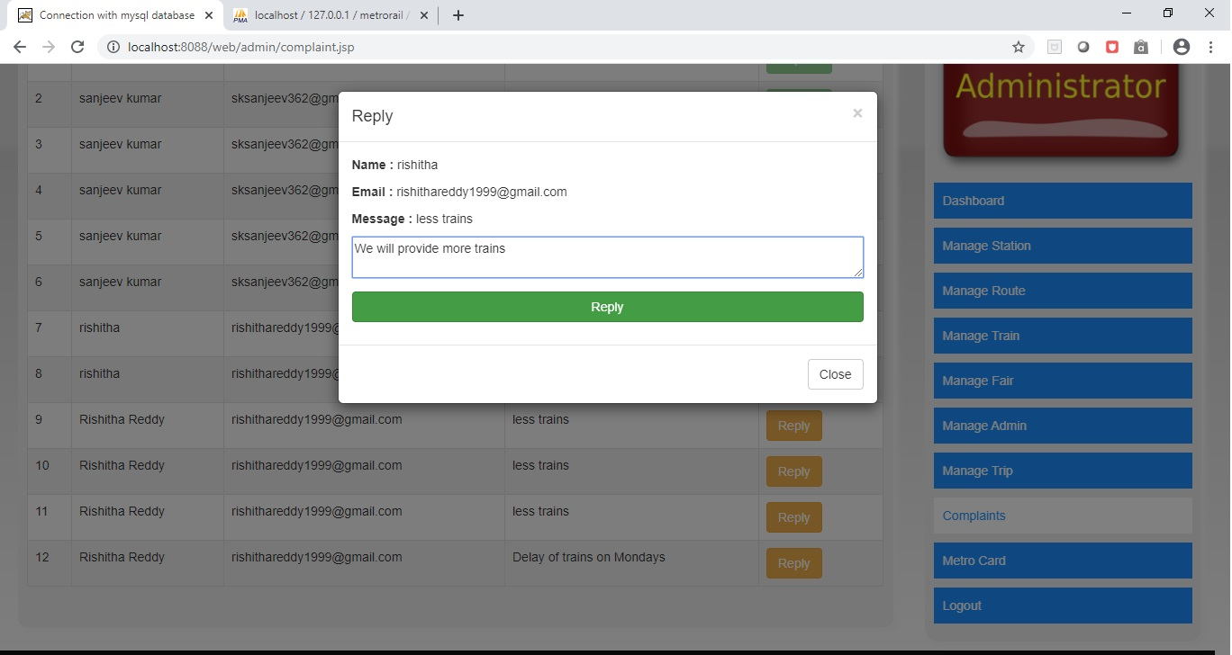

Figure 16: Reply to Complaints by Admin

The admin can reply to the complaints filed by the users.

1. **FUTURE SCOPE**

Since currently Refundable system in not implemented in this web app. So, in future we can solve this problem by adding refundable option also for users. Also, we need to test this web app time to time as for to check if everything working properly in the future. In future, we must also have sub-admins where admin gives permissions to access specific features instead of having access to the whole site. This option limits on some access for subordinates while the entire site can only be accessed by admin. A number of features can be added to the system in future like watch me module and also each admin can have separate permissions.

1. **CONCLUSION**

The project entitled Metro Rail Management online was completed successfully. The system has been developed with much care and free of errors and at the same time it is efficient as well as less time consuming.

The purpose of this project was to develop a web application for metro rail management. An admin module is where the admin can view and reply to complaints, issue smart card, add stations, add train, add routes, add and update fair details, add trips and also add a new admin. There is a complaint management system where users can file complaints regarding their issues. The system also contains an online ticket recharge module where users can recharge their smart cards online through the site.

This project helped us in gaining valuable information and practical knowledge on several topics like designing web using HTML, CSS, JSP, JS, usage of responsive templates, designing of android applications, and management of database using MySQL . The entire system is secured. Also, the project helped us to understand about the development phases of a project and software development life cycle. We learned how to test different features of a project. There is a scope for further development in our project to a great extent.

1. **REFERENCES**
2. Cody Lindley ,”Java Script Enlightenment", First Edition, ECMA-262 ,2007
3. Google
4. Stack overflow